Jaime Rodriguez

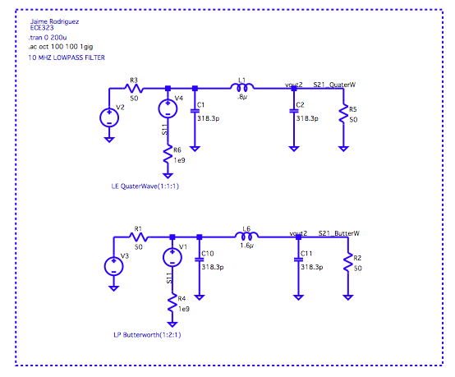

Figure 1, Filter Schematic

ECE 323

Filter Simulation HW 4

In this assignment we studied the differences between a (1:1:1) quarter wave filter and a (1:2:1) butterworth filter, we scaled the prototype values using 50ohm terminations and a frequency of 10MHz.

We can see the frequency response curves of both filters down below; we notice that the butterworth filter has a sharper response, and the quaterwave filter has a slight peak at the cutoff frequency. Using this same plot we study the phase response and measure where the frequencies have a phase equal to 90 and 180-degree difference, this was also verified with a transient response below.

Next I varied the resistance of the end termination, and we see that the response is as we expected, as the resistance is increased the 50ohm line begins driving a higher impedance which gives the system some gain when the resistance is decreased we see some loss in the system.

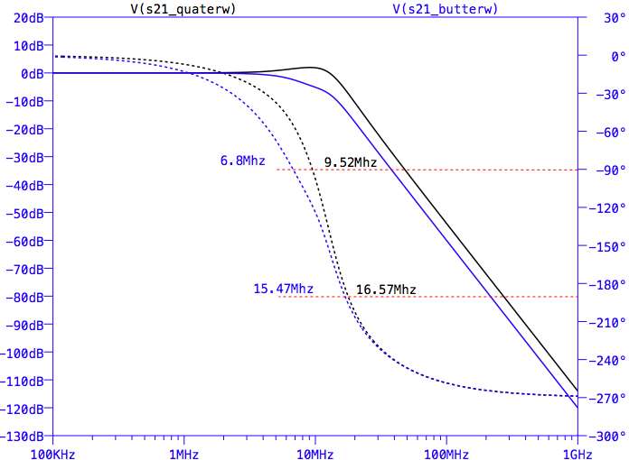

Figure 2, Filter Frequency response

Figure 3, Varying termination resistance

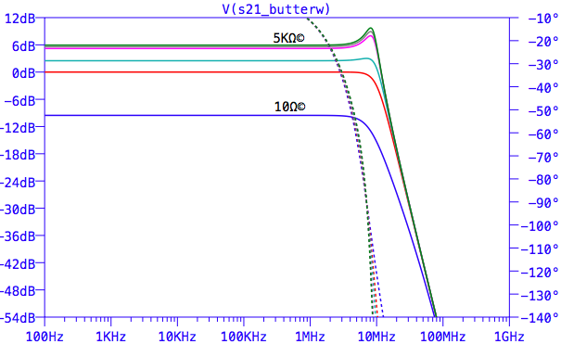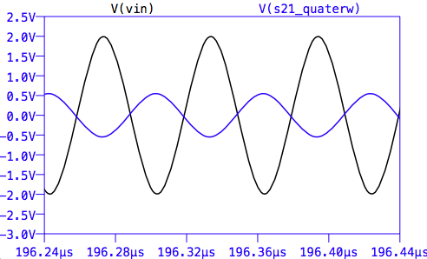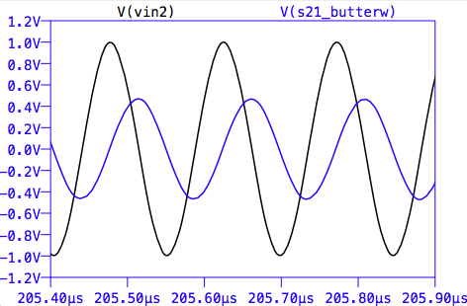

Figure 4, 180 and 90-degree phase shift